­

**Nothing Should**

**Hold a Kid Back.**

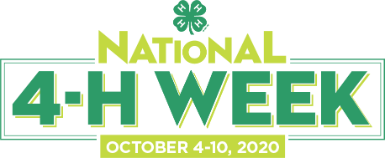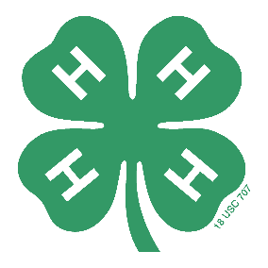

Insert Local Info Here

**Create #Opportunity4All**

**Kids this National 4-H Week**

**Kansas State University Agricultural Experiment Station and Cooperative Extension Service.**

K-State Research and Extension is an equal opportunity provider and employer.